

Advance Web

**Programing Hp Killers**

**PROJECT UNIT 1**

**Nrc:**5119

**Date** :3th June 2022

**GAME SERVER PAGE**

**1. Introduction**

Game Servers are essential in the administration and infrastructure of video games through web servers, both as a local server to host video game games or the purchase of improvements or objects to improve your progress or experience, all through an internet connection.

Wow (Word of Warcraft) is an online multiplayer video game and is characterized by its role dynamics developed by Blizzard Entertainment, the main objective is to learn, and be competitive to achieve a specific position, so your statistics and records are essential to For this reason, it is the client of this project.

For time reasons, we would keep the web application as simple as possible in the processes, trying to meet the different requirements that the client needs.

**2. Project participants**

Yanzapanta Ontaneda Bryan Sebastian

Yépez Chandi Christopher

Zapata Sandoval Jonathan Ismael

Zapata Zapata Sebastian Alexander

**3. Description of the current system**

The system is responsible for displaying, organizing, configuring users and sharing different information about the client's world of warcraft (WoW) private server.

**4. Objectives of the project**

* The web application must present access to the private WoW server
* The web application must provide services such as the creation and configuration of profiles or user access management
* The web application should display a dynamic and interactive user interface

**5. Functional requirement**

* The application must record each user activity: purchases, statistical records, and activity.
* The application must contain account settings
* The application updates the news regarding the news of the Wow game
* The server store provides the information of each object that includes its price, description and its time in stay
* The system takes care of each purchase record and update of user objects
* The system will record each modification in the user's account (change of user registration as nickname or account deletion)
* The system will be able to record the entry of new accounts
* The system must contain a tab to download resources from the WOW server
* The system must have a forum where users can register their concerns
* The system must implement contact information through applications such as facebook, twitter and instagram

**6.NonFunctional Requirements**

* The application must have a dynamic and attractive interface for the user.
* The application must be connected to a database SQL
* The system must have a support tab detailing the possible errors that the 9private WOW server can make

**7. Tools**

* Html
* Css
* JavaScript
* Php

**7.Diagrams and Architecture**

**Architecture design**

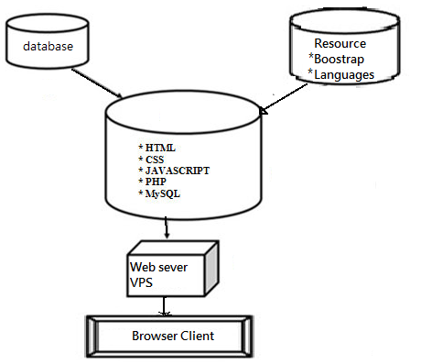

**Use case**

[**https://lucid.app/lucidchart/7d1a1219-8623-416c-aca0-0f25044db4d4/edit?invitationId=inv_97fb5554-89bb-477f-9120-0ad99c9014cb#**](https://lucid.app/lucidchart/7d1a1219-8623-416c-aca0-0f25044db4d4/edit?invitationId=inv_97fb5554-89bb-477f-9120-0ad99c9014cb#)

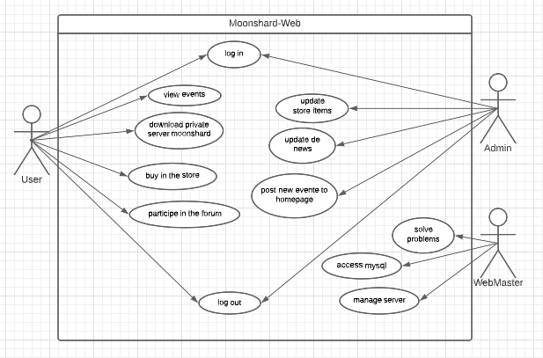

**Class Diagram**

**https://lucid.app/lucidchart/5b204f1d-27ad-4777-93bb-6338bd3e5225/edit?viewport_loc=-24%2C71%2C2042%2C857%2C0_0&invitationId=inv_f2a72e5d-e3d4-43be-b358-34cc9d4d634a#**

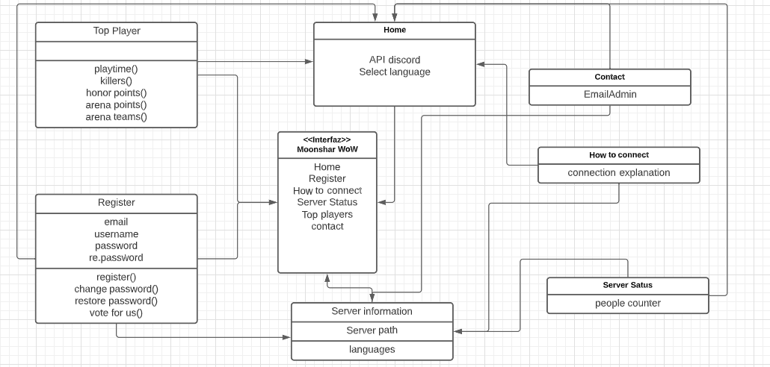

**8. Code**

**Our code is in github**

[**https://github.com/jizapata3/HP_Killlers_GameServerWebApp_5119_AWD**](https://github.com/jizapata3/HP_Killlers_GameServerWebApp_5119_AWD)

**9.Image Captures**

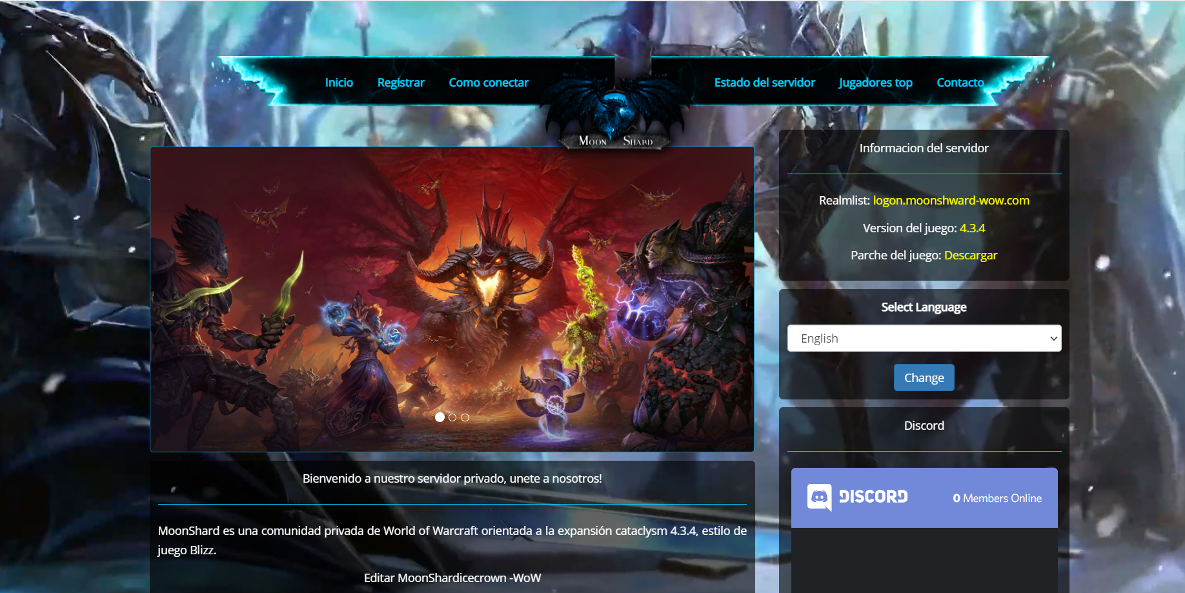

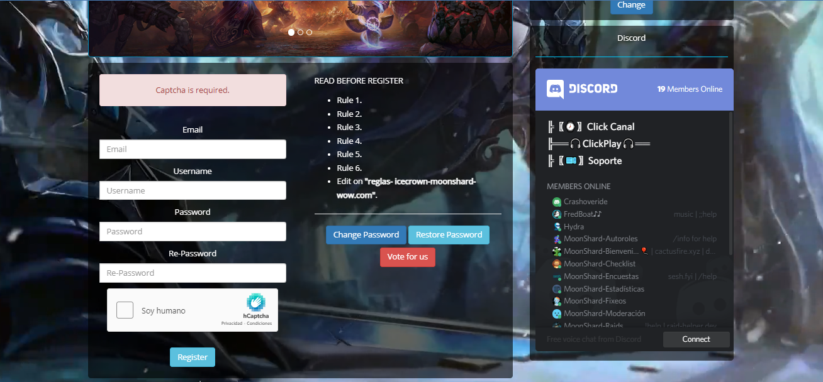

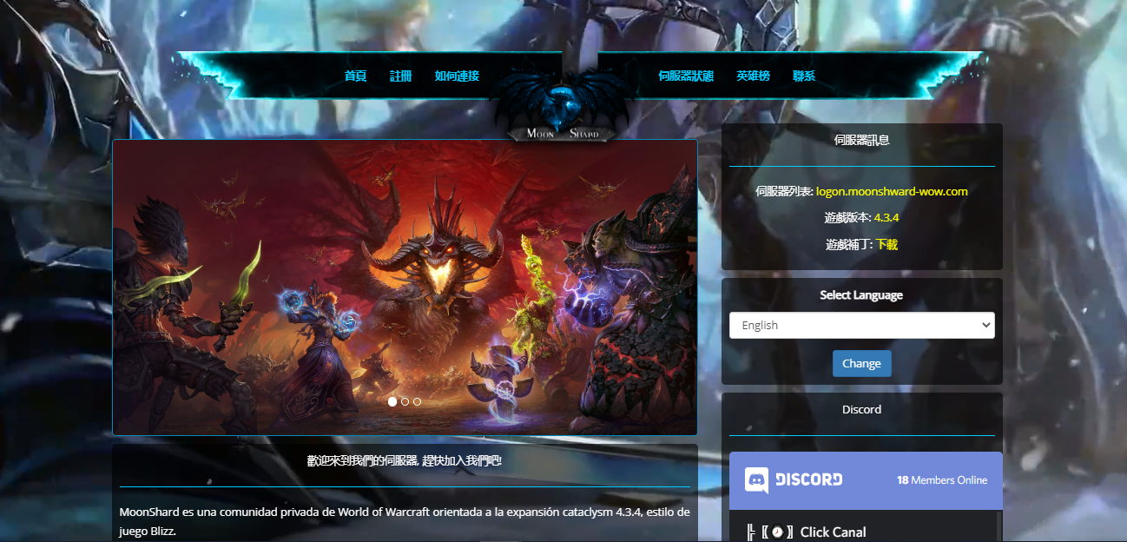

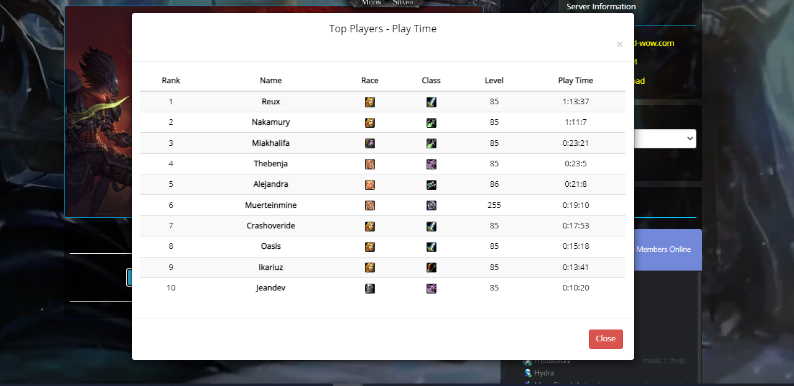

**10. Solution Error**

**About the error detected with another classmate. these were resolved**

* **~~1.Fix 404 error~~**
* **~~2. Fix url~~**
* **~~3.Fix Account~~**
* **~~4. Fix discord API~~**

**Example:**

**Fix 404 error**

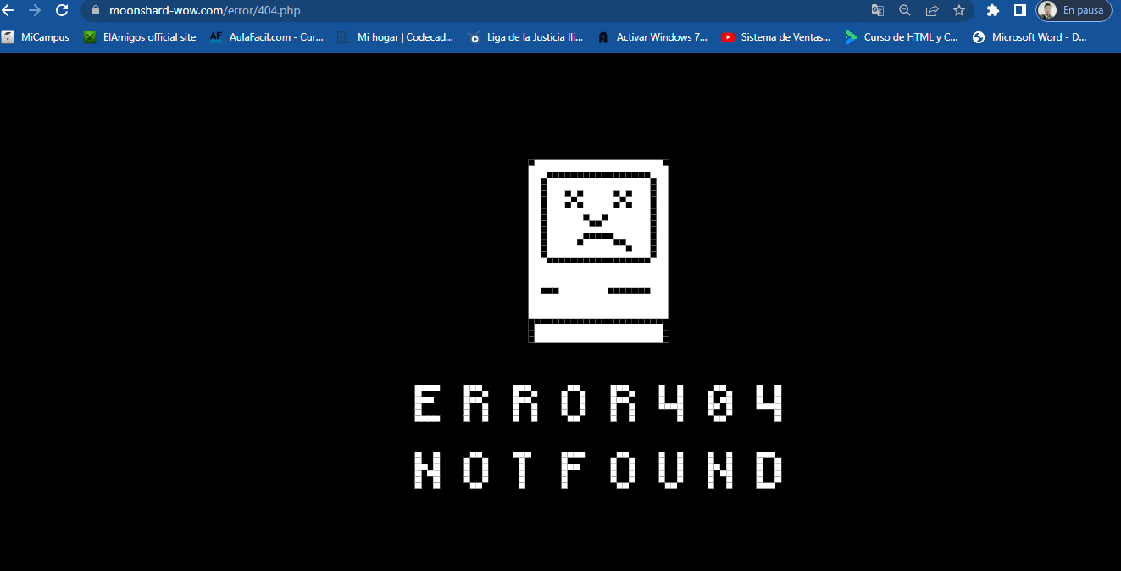

**Discord API no functional Discord API functional**

 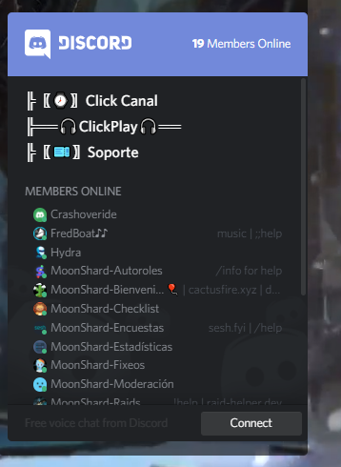

**10.Conclusions**

It has been possible to develop the website successfully, guiding us through requirements raised through our client WOW.

The video game server has a user administration together with the connection to the SQL database and also the page is uploaded within a VPS